**CRYPTO GENERATOR OVER NODEJS**

REF:

<http://vancelucas.com/blog/stronger-encryption-and-decryption-in-node-js/>

<http://lollyrock.com/articles/nodejs-encryption/>

IN ORDER TO CREATE OR CRYPTO GENERATOR FILE IN OUR EXPRESS.JS APP, WE HAVE TO USE A BUILT IN NODE MODULE CALLED ***crypto***

1. FIRST WE HAVE TO CREATE NEW FILE TO ENCRYPT AND DECRYPT TEXT FOR OUR PURPOSE:

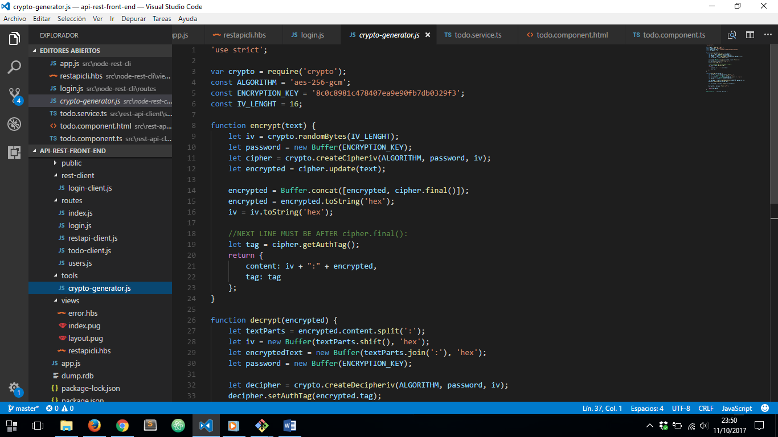

1. IT’S TIME TO CONFIGURE OUR CRYPTO GENERATOR

IMPORTING DEPENDENCIES:



SPECIFYING NEEDED VALUES:

|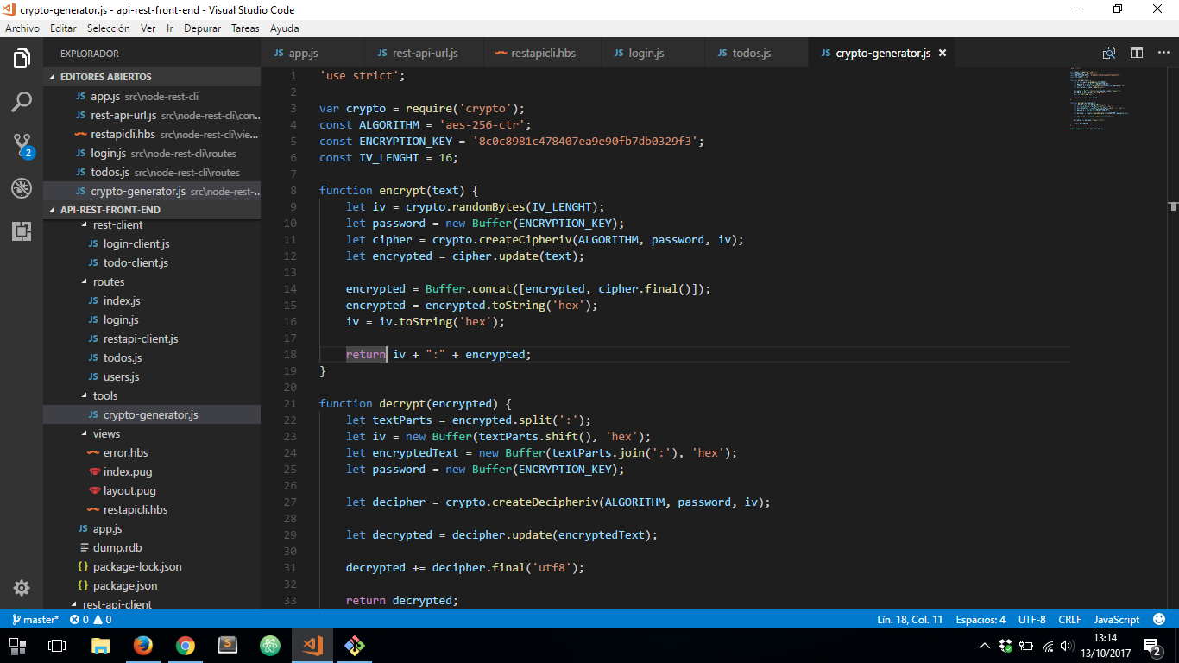

ENCRYPT METHOD USING ***AES-256-CTR*** ALGORITHM, A CUSTOM ENCRYPTION KEY AND AN INITIALIZATION VECTOR OF 16 CHARACTERS WHICH WILL HELP US TO DECRYPT OUR TEXT:



LAST FUNCTION WILL RETURN A JSON OBJECT WHICH CONTAINS OUR ENCRYPTED TEXT AND A TAG TO DECRYPT IT

THEN IT’S TIME TO CREATE OUR DECRYPT FUNCTION:

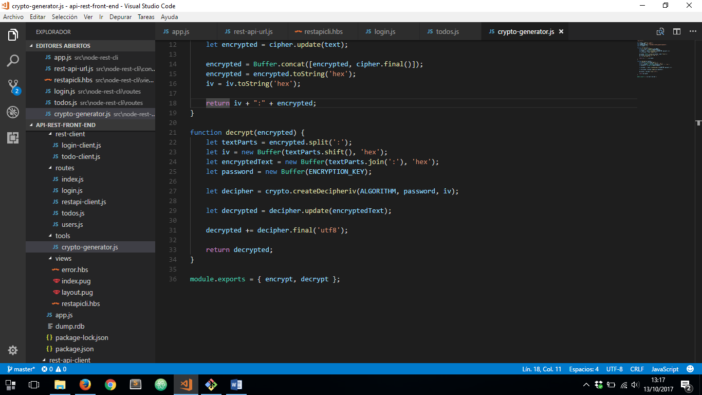

AND THEN WE HAVE TO EXPORTS BOTH METHODS BECAUSE WE DEPLOYING OUR NODEJS SERVER OVER AN EXPRESS GENERATOR APP

FINNALLY WE ARE ABLE TO USE THAT FUNCTIONS:

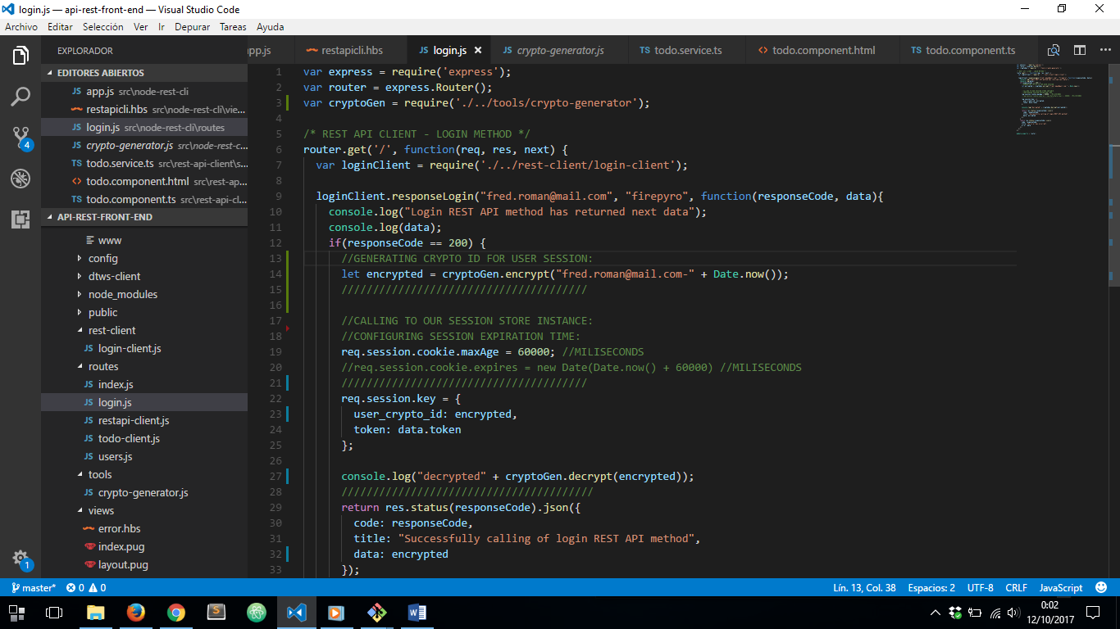

RESULT:

